AI Declaration
In my project I used Claude AI to help me sort statements from the scenario and refine it, helping me with influence decisions, and keep me on track of the brief. In relation to the rest of my work, any diagrams, Gherkin code and analysis were done by me.
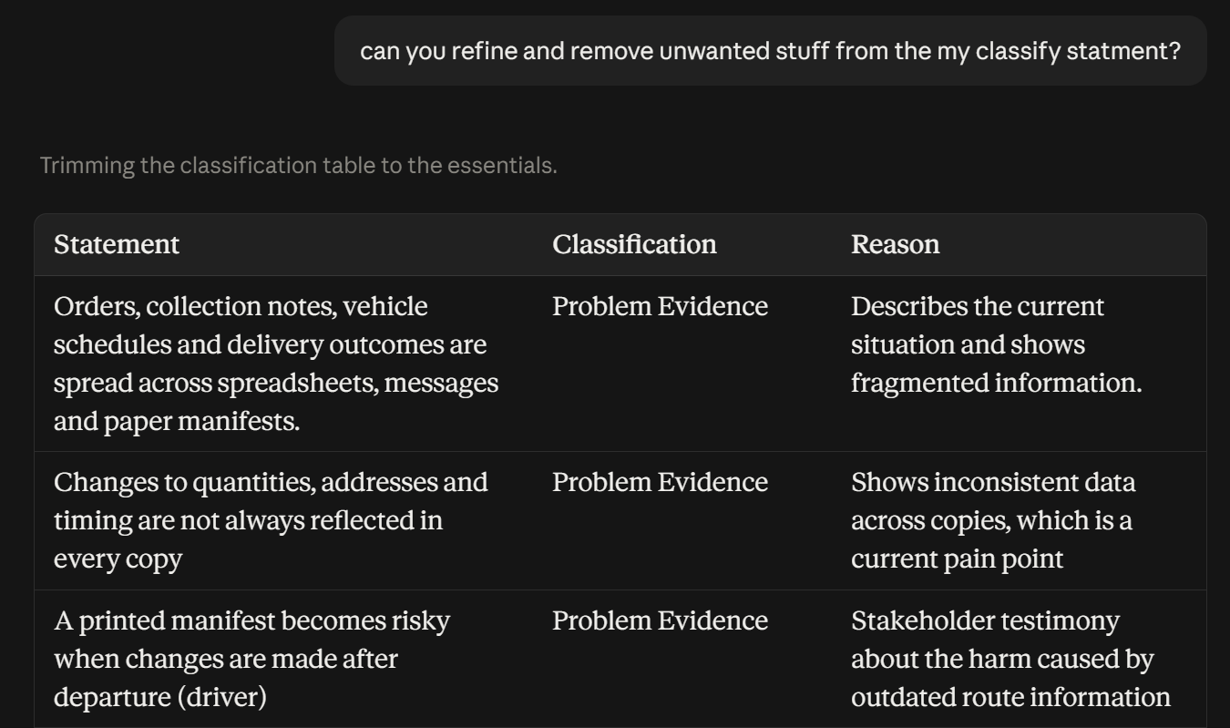
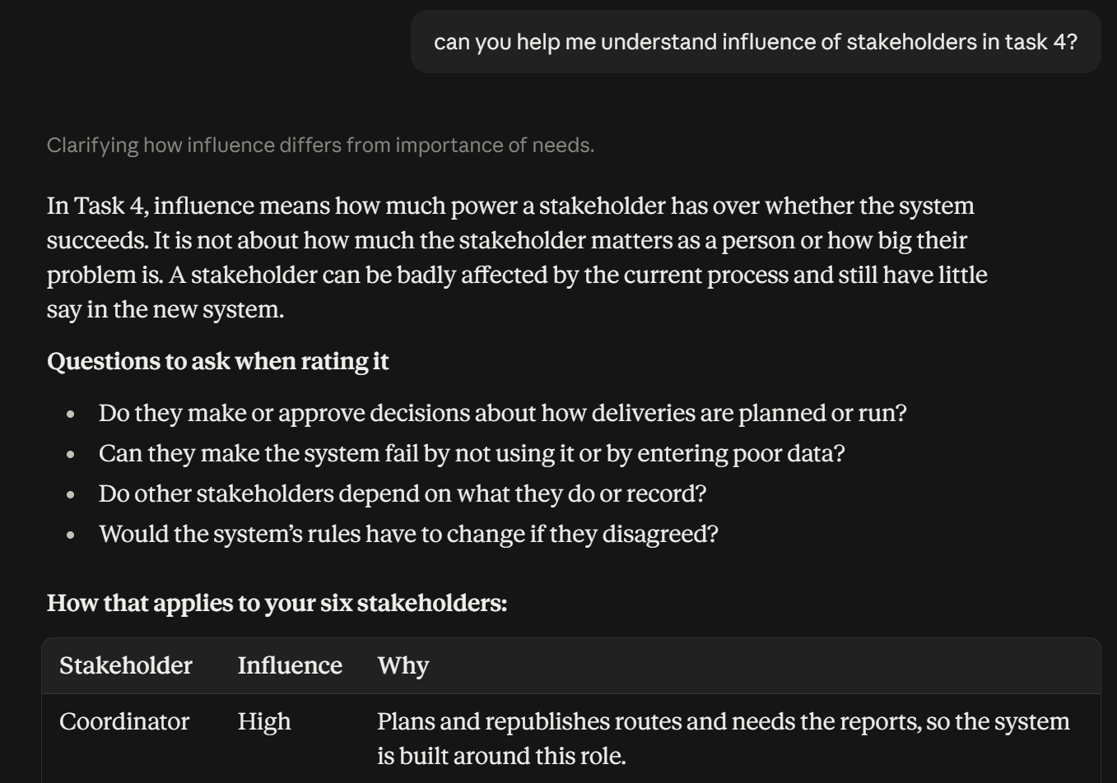
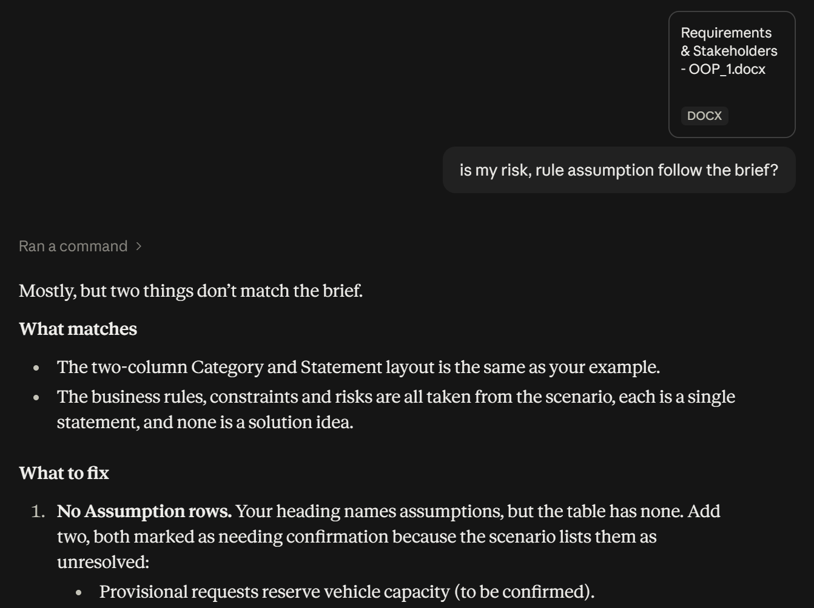

References
For the plantuml I used some stylistic choices that I take from this website:
plantuml.com/fr/theme-gallery
Also, I was following the video tutorial on YouTube for building up diagrams:
PlantUML - beautiful quick diagrams to explain your models

